**The LNM Institute of Information Technology**

**ECE and CCE**

|  |
| --- |
| **CVFA**  **Endterm Term** |

**Time: 2hrs 30min Date:** 08/12/2021 **Max. Marks: 40**

***Instructions:*** *1) There are total of 6 questions and all questions are compulsory*

Q1. [4+4=8]

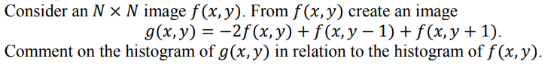

1. Will the output of histogram equalization of above two images i.e. $f\left(x,y\right) and g\left(x,y\right)$ be same? Support your answer with an example.

Q2. [6]

Consider the following three Laplacian filters A, B, and C

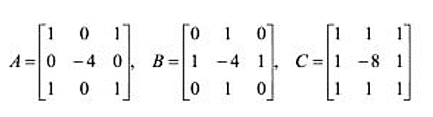

If we filter a given image I by using filters A, B, and C respectively to obtain the sharpened images IA, IB, and IC. What can you say about these filtered images? (Hint: how do their results differ in terms of image sharpness?)

Q3. [3+5=8]

What is a USAN? How the corners in an image are detected using SUSAN technique.

Q4. [4+2=6]

Explain how the classification process works using ANN? How does the hidden neurons play an important role in ANN?

Q5. [2+4=6]

How is the Harris corner detector different from SIFT features? Explain the steps (in short) of the SIFT feature detector.

Q6. [3+3=6]

MATLAB Task

1. An input image (input.png) and an output image (output.png) is provided. Perform a MATLAB task to convert the input to output. You can use any solution (single step or multiple steps) to solve the task.
2. An input image (input2.png) and an output image (outut2.png) is provided. Use any image sharpening technique to covert the input to output.

*Note: Please don’t worry if your output is not exactly same as the given output*